

A Project Report

On

**Hospital Management System**

**Title**

**Ace Hospital**

By

**Aakansha Shrivas**

**B.Sc. IT**

**Batch: - 2020 – 4970 Centre: Thane, Mumbai**

Under the Guidance of

**Jayant V.**

Technical Trainer

EduBridge

(School of coding)

**Introduction**

Ace Hospital project explains about the Hospital Management System. This project mainly explains the various actions that are most important while being in hospital. This project keeps the track of all the necessity information and data are registered, updated as well as including doctor details.

Our Project Includes:

* Appointment Module
* Department Module
* Doctor Details
* Feedback Details
* Patient Module
* User Module
* Nurse Module

I have developed this Application in Java, JSP, Servlets and MySQL. It’s a web-based projects so I have used HTML, CSS also. The aim of the project is to keep the record of all the data inserted into the hospital system to help in managing hospital data online.

Every module contains different login id and password which allows them to login and access the system. The modules include patient details and allows patient as well are given access to get logged in.

It includes insert, update, delete, and viewing of the data. There is also option of appointment viewing and on the top of it allows to provide the value able feedback from the user.

**Software Requirements**

**Front end:** Java/J2EE technologies (Servlet, JSP), HTML, CSS, JDBC.

**Back end:** MySQL.

**Middleware/Server:** Apache Tomcat v9.0.

**IDE:** Eclipse IDE for Java EE Developers

**Browser:** Best result on Google Chrome

**Operating System:** Window XP (Minimum).

**ERD (Entity Relationship Diagram):**

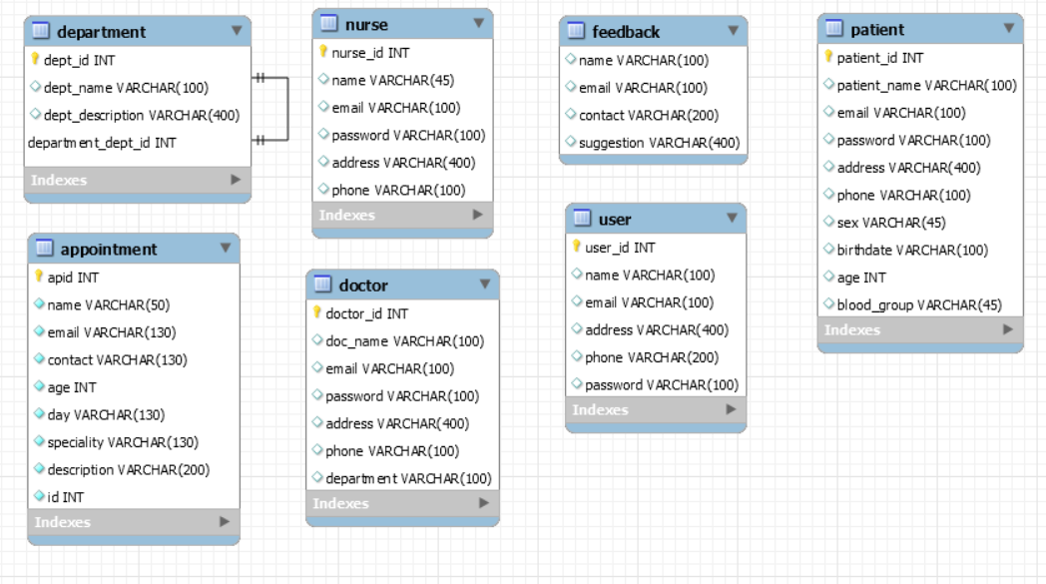

**Data Dictionary**

CREATE TABLE `**appointment**` (

`apid` int(11) NOT NULL auto_increment,

`name` varchar(50) NOT NULL,

`email` varchar(130) NOT NULL,

`contact` varchar(130) NOT NULL,

`age` int(11) NOT NULL,

`day` varchar(130) NOT NULL,

`speciality` varchar(130) NOT NULL,

`description` varchar(200) NOT NULL,

`id` int(11) NOT NULL,

PRIMARY KEY (`apid`)

) ENGINE=InnoDB DEFAULT CHARSET=latin1;

CREATE TABLE `**department**` (

`dept_id` int(11) NOT NULL auto_increment,

`dept_name` varchar(100) default NULL,

`dept_description` varchar(400) default NULL,

PRIMARY KEY (`dept_id`)

) ENGINE=InnoDB DEFAULT CHARSET=latin1;

CREATE TABLE **`doctor**` (

`doctor_id` int(11) NOT NULL auto_increment,

`doc_name` varchar(100) default NULL,

`email` varchar(100) default NULL,

`password` varchar(100) default NULL,

`address` varchar(400) default NULL,

`phone` varchar(100) default NULL,

`department` varchar(100) default NULL,

PRIMARY KEY (`doctor_id`)

) ENGINE=InnoDB DEFAULT CHARSET=latin1;

CREATE TABLE `**feedback**` (

`name` varchar(100) default NULL,

`email` varchar(100) default NULL,

`contact` varchar(200) default NULL,

`suggestion` varchar(400) default NULL

) ENGINE=InnoDB DEFAULT CHARSET=latin1;

CREATE TABLE `**nurse**` (

`nurse_id` int(11) NOT NULL auto_increment,

`name` varchar(45) default NULL,

`email` varchar(100) default NULL,

`password` varchar(100) default NULL,

`address` varchar(400) default NULL,

`phone` varchar(100) default NULL,

PRIMARY KEY (`nurse_id`)

) ENGINE=InnoDB DEFAULT CHARSET=latin1;

CREATE TABLE `**patient**` (

`patient_id` int(11) NOT NULL auto_increment,

`patient_name` varchar(100) default NULL,

`email` varchar(100) default NULL,

`password` varchar(100) default NULL,

`address` varchar(400) default NULL,

`phone` varchar(100) default NULL,

`sex` varchar(45) default NULL,

`birthdate` varchar(100) default NULL,

`age` int(11) default NULL,

`blood_group` varchar(45) default NULL,

PRIMARY KEY (`patient_id`)

) ENGINE=InnoDB DEFAULT CHARSET=latin1;

CREATE TABLE `**user**` (

`user_id` int(11) NOT NULL auto_increment,

`name` varchar(100) default NULL,

`email` varchar(100) default NULL,

`address` varchar(400) default NULL,

`phone` varchar(200) default NULL,

`password` varchar(100) default NULL,

PRIMARY KEY (`user_id`)

) ENGINE=InnoDB DEFAULT CHARSET=latin1;

**Screenshots:**

**Admin Login**

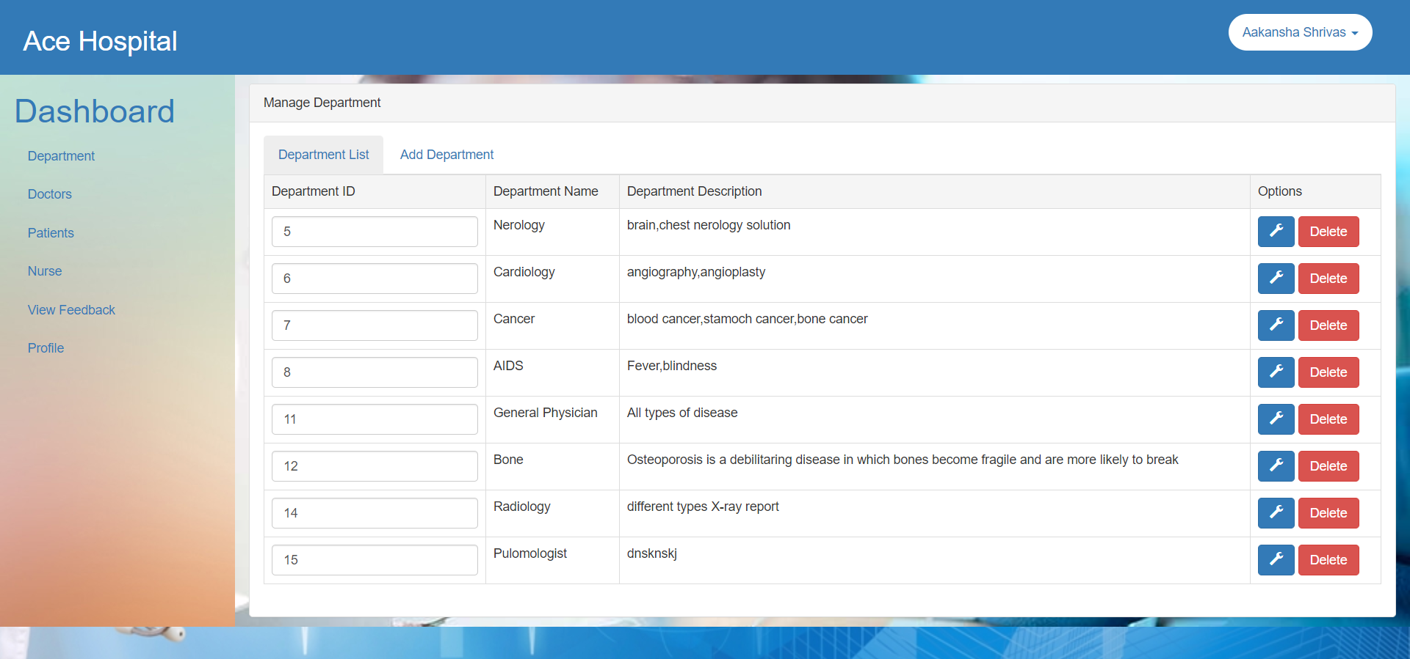

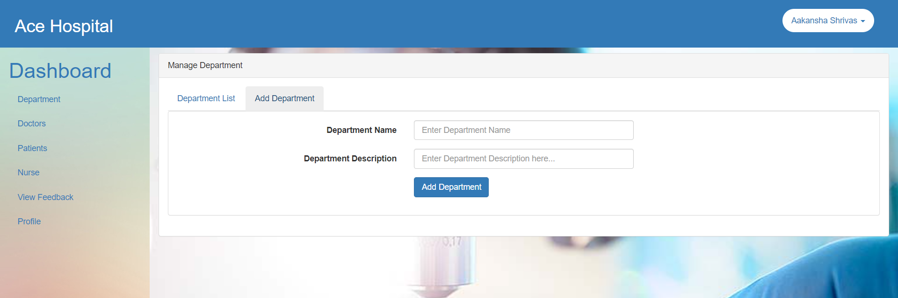

**User Login**

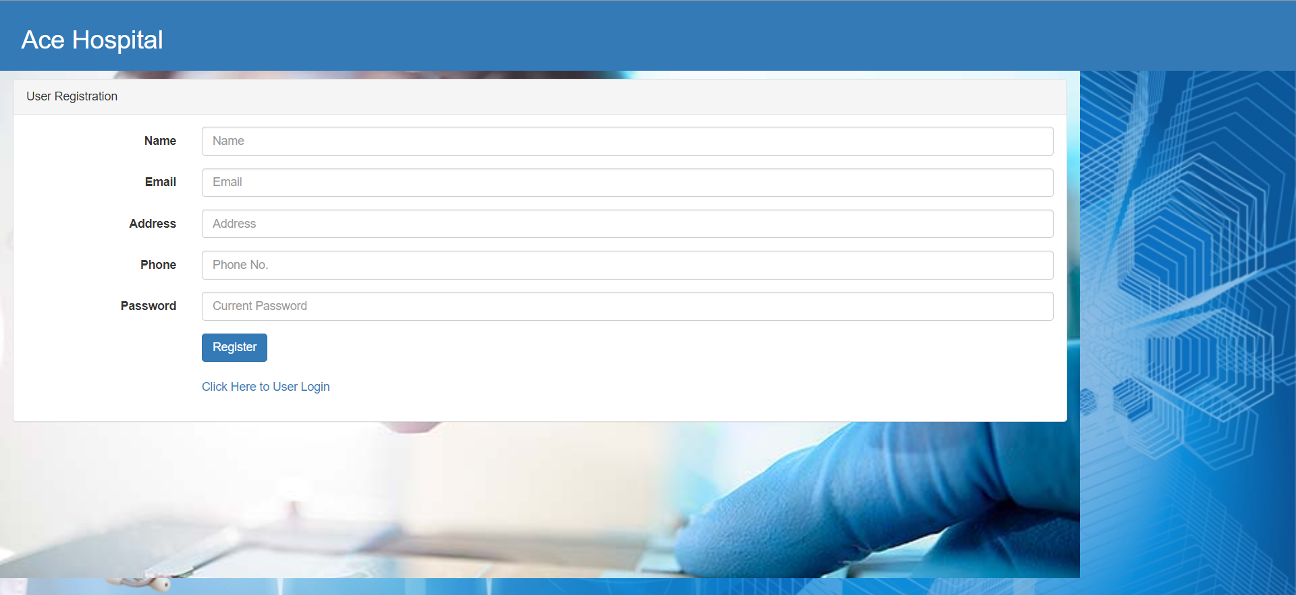

**Appointment module**

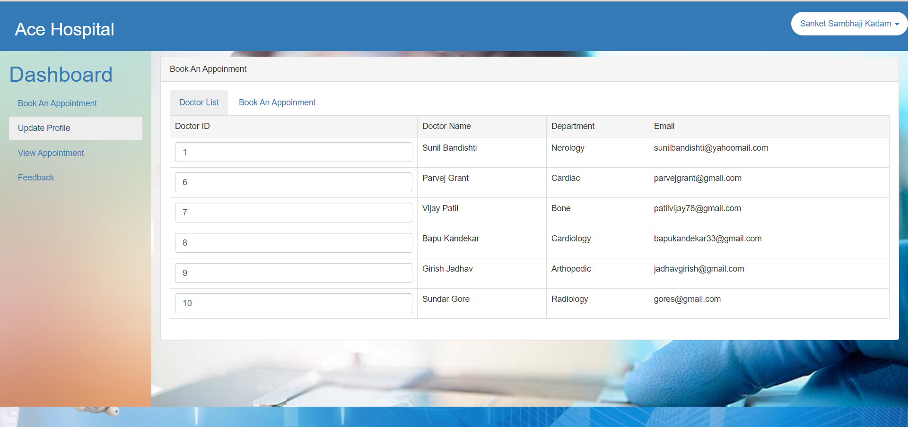

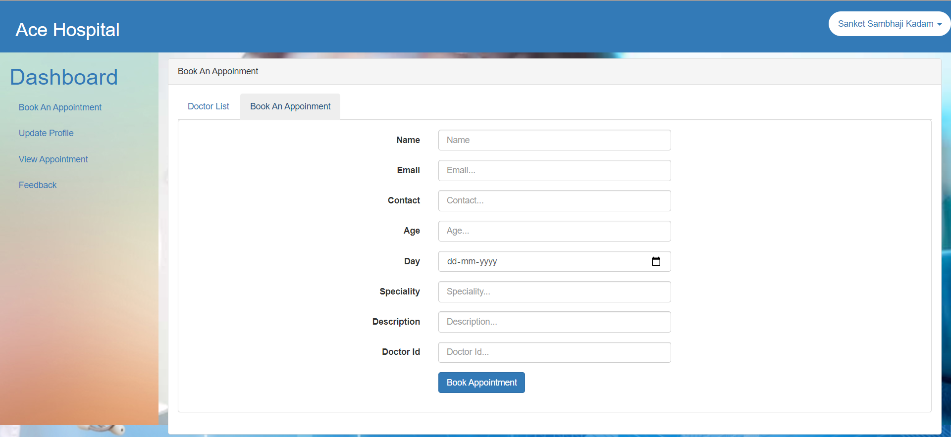

**Doctor Login**

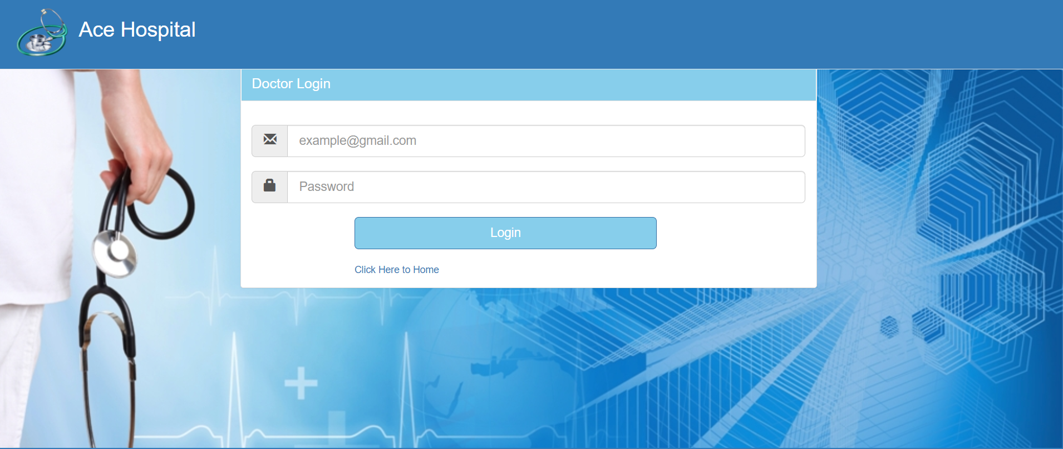

**Patient Login**

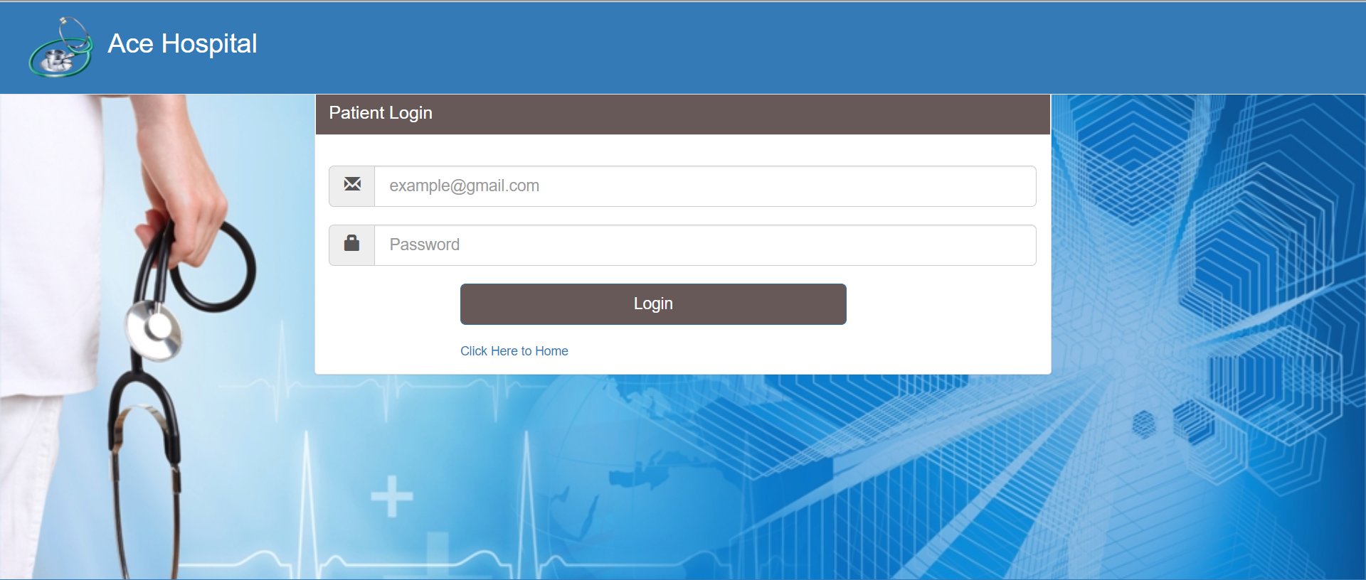

**Feedback**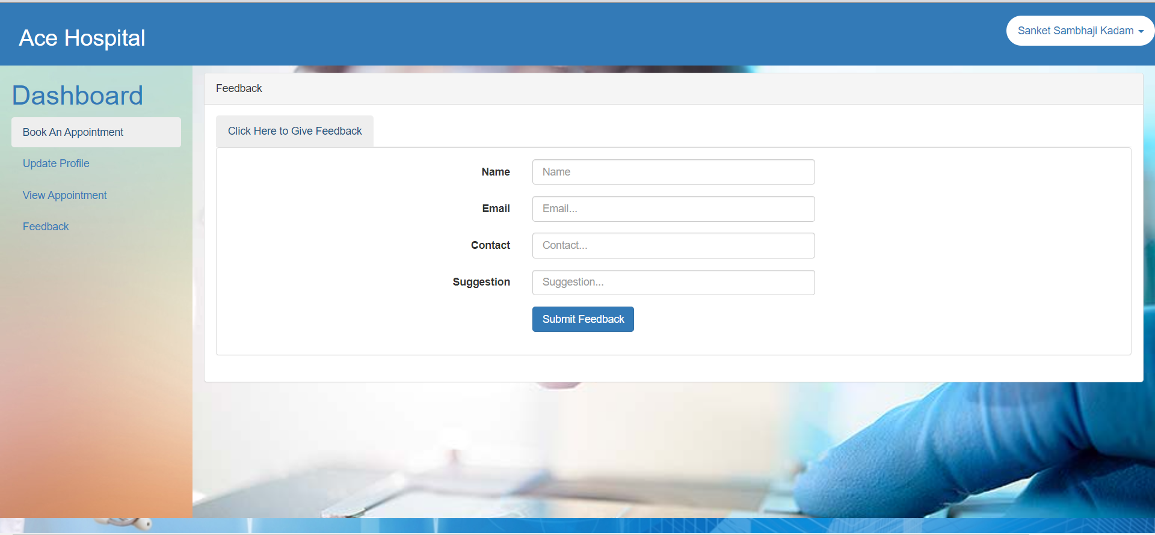

**Doctor Appointment**

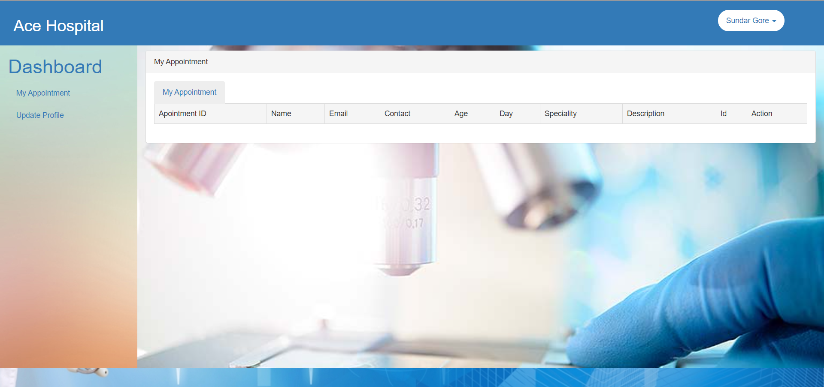

**Nurse**

